Case Study 1: Progressive Electricity Billing

1. Problem Statement
Calculate an electricity bill based on units used. The first 100 units cost ₹2 per unit, and units above 100 cost ₹3 per unit. A fixed charge of ₹50 is added.

2. Objectives
- Calculate the bill using conditional statements.
- Display the total amount payable.

3. Assumptions
- Units used cannot be negative.
- The fixed charge is ₹50.

4. Algorithm
1. Read units.
2. If units are negative, display invalid input.
3. If units <= 100, energy charge = units * 2.
4. Otherwise, energy charge = 100 * 2 + (units - 100) * 3.
5. Add fixed charge and display bill.

5. Flowchart
START → Input units → Validate → Calculate slab charge → Add ₹50 fixed charge → Display bill → STOP
For a drawn flowchart, use: oval for START/STOP, parallelogram for input/output, rectangle for calculations, and diamond for decisions.

6. Pseudocode
READ units
IF units < 0: DISPLAY invalid
ELSE IF units <= 100: charge = units * 2
ELSE: charge = 200 + (units - 100) * 3
bill = charge + 50
DISPLAY bill

7. Python Source Code

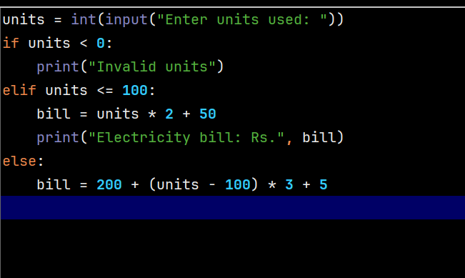8. sampleTest Cases
Test 1: 50 units → ₹150. Test 2: 120 units → ₹410.

Sample Output
Input: 120 units
Output: Electricity bill: Rs. 410

9. Conclusion
The program calculates an electricity bill using simple if-else conditions.

